CASE STUDY – DELTA TABLE OPERATIONS
Step 1: Create Example Data
from pyspark.sql.types import StructType, StructField, IntegerType, StringType

# Example data (10 records)
data = [
(1, "Lokanya", "IT"),
(2, "Gowrishankar", "CSE"),
(3, "Arun", "ECE"),
(4, "Priya", "IT"),
(5, "Kumar", "EEE"),
(6, "Meena", "CSE"),
(7, "Ravi", "MECH"),
(8, "Divya", "IT"),
(9, "Suresh", "CIVIL"),
(10, "Aarthi", "CSE")
]

# Define schema
schema = StructType([
StructField("id", IntegerType(), True),
StructField("name", StringType(), True),
StructField("department", StringType(), True)
])

# Create DataFrame
df = spark.createDataFrame(data, schema)

# Write as Delta Table
df.write.format("delta").mode("overwrite").save("/mnt/rawdata/employees")

# Register as SQL table
spark.sql("DROP TABLE IF EXISTS employees")
spark.sql("CREATE TABLE employees USING DELTA LOCATION '/mnt/delta/employees'")

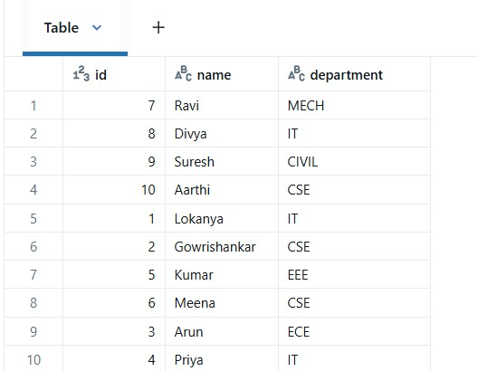

Step 2: Insert New Data
INSERT INTO employees VALUES (11, "Karthik", "IT");
INSERT INTO employees VALUES (12, "Swathi", "CSE");
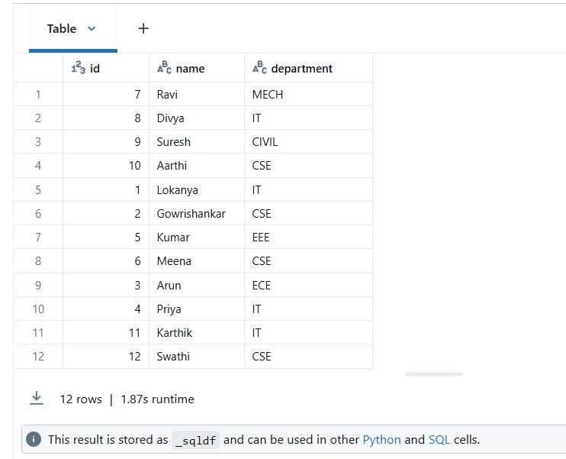
Step 3: Delete Operation
-- Delete employee from IT department
DELETE FROM employees WHERE department = 'IT';
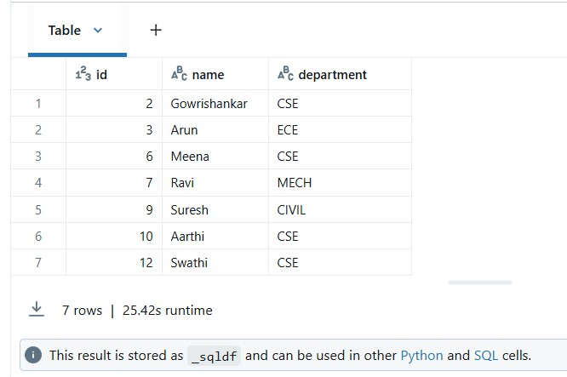

Step 4: Update Operation
-- Update department of Ravi from MECH → AI
UPDATE employees SET department = 'AI' WHERE name = 'Ravi';
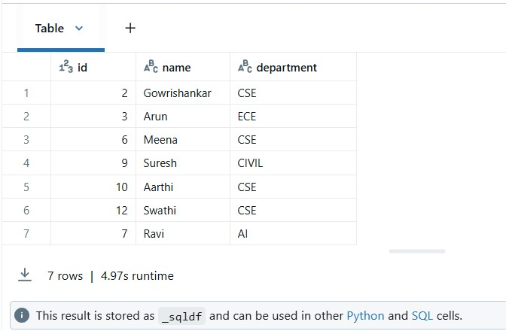
Step 5: Query Operations
-- 1. Count by department
SELECT department, COUNT(*) AS total FROM employees GROUP BY department;
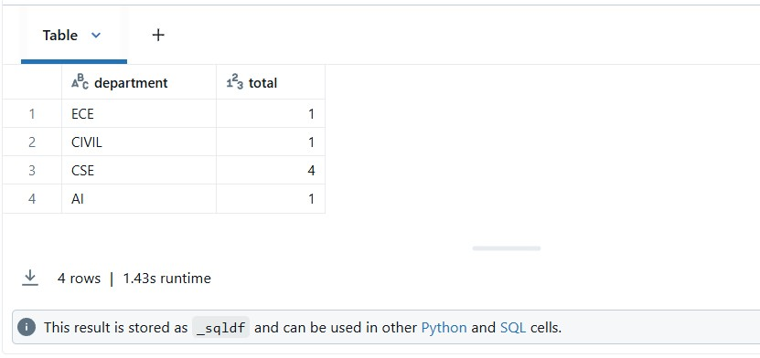

-- 2. Get employees from IT department
SELECT * FROM employees WHERE department = 'IT';
